**生信分析报告**

**项目标题： 清心莲子饮网络药理学分析 ;**

**单 号： BSJF240734 ;**

**分析人员： 黄礼闯 ;**

**分析类型： 生信分析 ;**

**委 托 人： 林波 ;**

**受 托 人： 杭州铂赛生物科技有限公司 .**

# 1 分析流程

1. 通过网络药理学筛选出清心莲子饮和CKD的共同靶点
2. 根据上一步靶点的相关信号通路与铁死亡相关信号通路进行通路富集

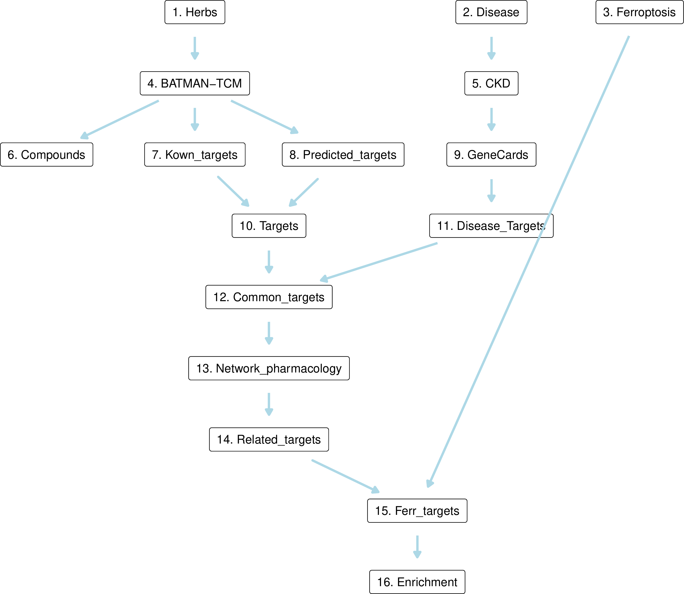

**Fig.** Unnamed 1

**(File path: Figure+Table/1.0_分析流程_{#abstract}/Unnamed-1.pdf)**

# 2 材料和方法

## 2.1 数据分析平台

在 Linux pop-os x86_64 (6.9.3-76060903-generic) 上，使用 R version 4.4.2 (2024-10-31) (<https://www.r-project.org/>) 对数据统计分析与整合分析。

## 2.2 BATMAN 网络药理学 (Dataset: QINGXIN)

从数据库 BATMAN-TCM ((2024, **IF:16.6**, Q1, Nucleic acids research)1) 中获取 CHI SHAO, MAI DONG, CHE QIAN ZI, REN SHEN, DI GU PI, LIAN ZI, HUANG QIN, GAN CAO, HUANG QI 等中药的成分、靶点数据。(即中药：莲子, 麦冬, 黄芩, 地骨皮, 人参, 车前子, 甘草, 赤芍, 黄芪)。 使用 BATMAN-TCM 数据库中的 known_target_proteins 作为成分靶点。此外，还使用了 BATMAN-TCM 数据库中的 predicted_target_proteins 作为成分靶点，并设定 分数 cut-off 为 0.9。合并靶点数据。以 BiomaRt ((2009, **IF:13.1**, Q1, Nature protocols)2) 对靶点信息的 entrez_id 转化为基因 Symbol (hgnc_symbol) 。 以 PubChemR 获取化合物同义名 (Synonym)，按正则表达式 (Regex) 匹配化合物简短的同义名用以化合物注释。

## 2.3 GeneCards 基因获取 (Dataset: CKD)

从 GeneCards 数据库 (2016, **IF:NA**, NA, Current protocols in bioinformatics)3 获取 Chronic kidney disease 相关的基因集，得分 cut-off 为 3。

## 2.4 FerrDb 铁死亡调控因子 (Dataset: FERR)

从数据库 FerrDb V2 (2023, **IF:16.6**, Q1, Nucleic acids research)4 获取与铁死亡相关的调控因子或铁死亡与疾病之间的关联信息 <http://www.zhounan.org/ferrdb/current/>。

## 2.5 富集分析 (Dataset: COMMON)

以 ClusterProfiler R 包 (4.15.0.2) (2021, **IF:33.2**, Q1, The Innovation)5进行 KEGG 和 GO 富集分析。 以 pathview R 包 (1.46.0) 对选择的 KEGG 通路可视化。

# 3 分析结果

## 3.1 BATMAN 网络药理学 (QINGXIN)

各中药的化合物组成统计：CHE QIAN ZI (n=85) , CHI SHAO (n=238) , DI GU PI (n=114) , GAN CAO (n=509) , HUANG QI (n=248) , HUANG QIN (n=299) , LIAN ZI (n=48) , MAI DONG (n=86) , REN SHEN (n=604) 。共包含化合物 272 个 (非重复)。 共包含靶点 1856 个 (非重复)。

Fig. UpSet 图展示了中药各组成成分之间的交集 (中药名为拼音)。左侧横柱状图展示了各中药对应化合物数量。右侧展示了交集数目。各中药的化合物数目为数据库包含的化合物数量。数目最多的为 REN SHEN (n=604)；数目最少的为 LIAN ZI (n=48)；平均数目 248。 Fig. UpSet 图展示了中药的所有靶点 (中药名为拼音) 。该靶点是通过加和所有中药成分的靶点实现的。数目最多的为 REN SHEN (n=1209)；数目最少的为 LIAN ZI (n=82)；平均数目 613。

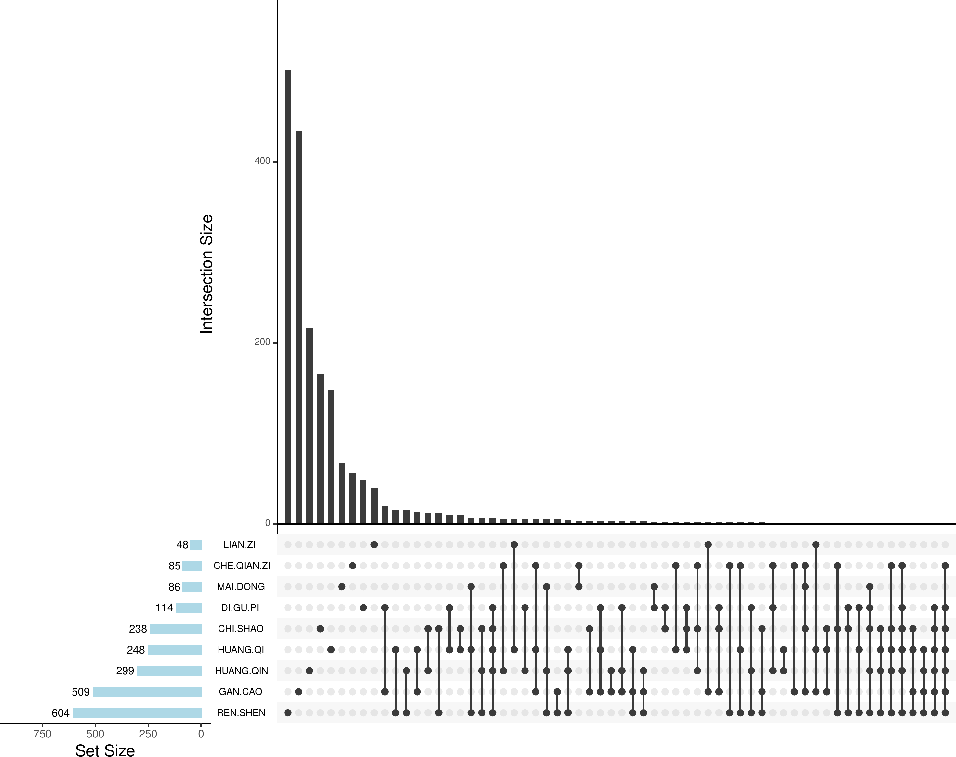

**Fig.** Intersection of herbs compounds

**(File path: Figure+Table/3.1_BATMAN_网络药理学_(QINGXIN)/Intersection-of-herbs-compounds.pdf)**

* All_intersection:

**(See: Figure+Table/3.1_BATMAN_网络药理学_(QINGXIN)/Intersection-of-herbs-compounds-content)**

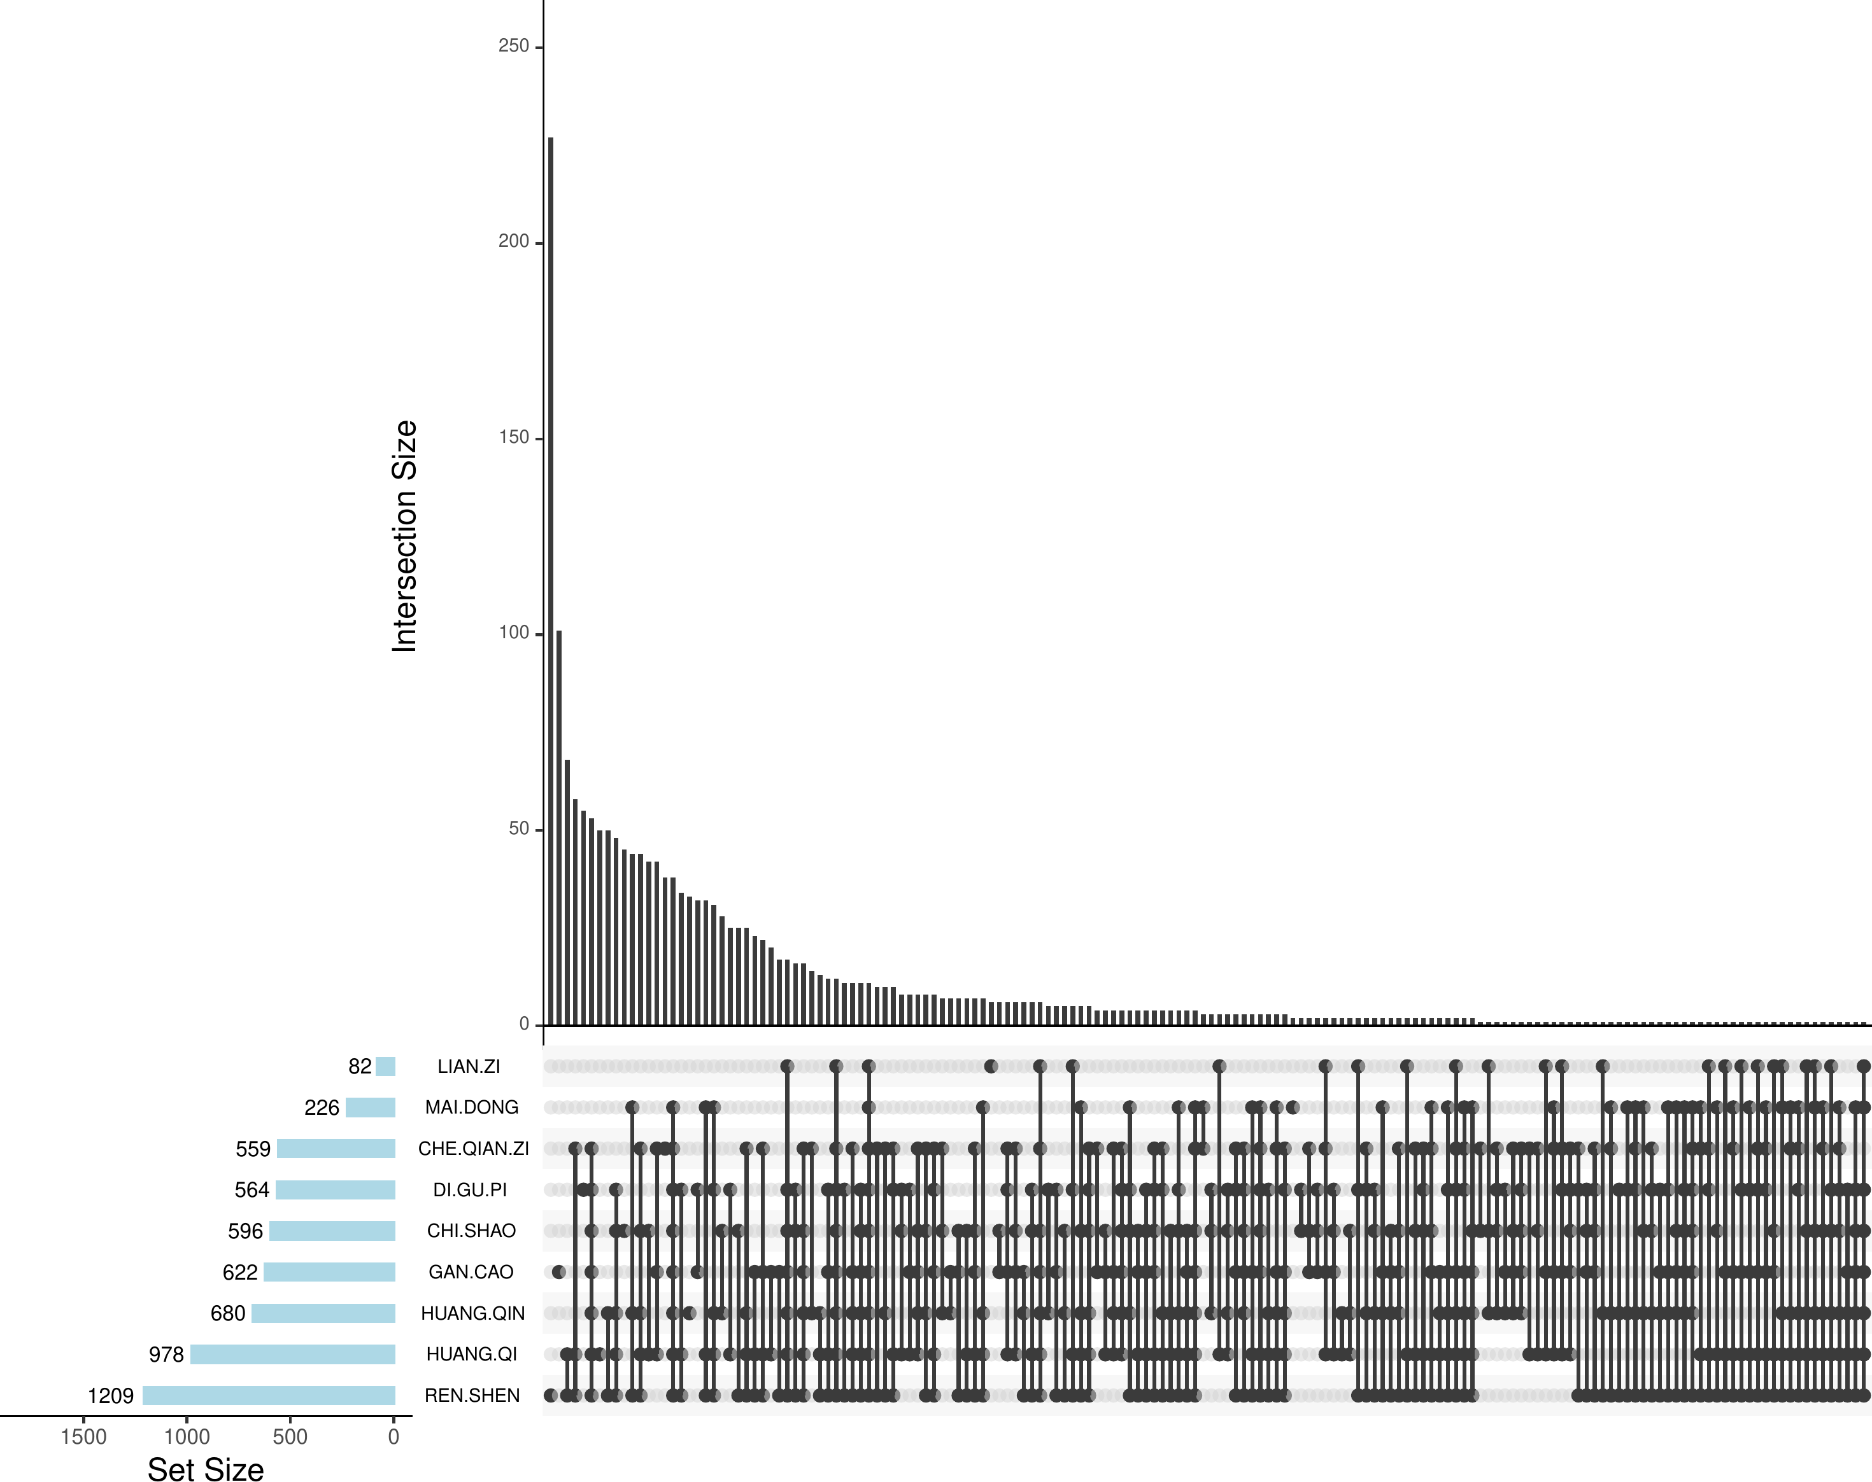

**Fig.** Intersection of herbs all targets

**(File path: Figure+Table/3.1_BATMAN_网络药理学_(QINGXIN)/Intersection-of-herbs-all-targets.pdf)**

* All_intersection: HMOX1, CASP3, NA, CASP9, MAPK1, MAPK3, BCL2, AKT1, STAT3, PPARA, TLR4

**(See: Figure+Table/3.1_BATMAN_网络药理学_(QINGXIN)/Intersection-of-herbs-all-targets-content)**

## 3.2 GeneCards 基因获取 (CKD)

从 GeneCards 取得的靶点数据，统计为 Functional Element (n=11) , Genetic Locus (n=1) , Protein Coding (n=675) , Pseudogene (n=1) , RNA Gene (lncRNA) (n=20) , RNA Gene (miRNA) (n=28) , RNA Gene (tRNA) (n=2) 。共 738 个靶点。

**Tab.** CKD disease related targets from GeneCards

| Symbol | Description | Category | UniProt ID | GIFtS | GC id | Score |
| --- | --- | --- | --- | --- | --- | --- |
| COL4A4 | Collagen T... | Protein Co... | P53420 | 55 | GC02M226973 | 34.39 |
| NPHS2 | NPHS2 Stom... | Protein Co... | Q9NP85 | 54 | GC01M179554 | 31.78 |
| COL4A5 | Collagen T... | Protein Co... | P29400 | 56 | GC0XP108439 | 30.73 |
| UMOD | Uromodulin | Protein Co... | P07911 | 55 | GC16M027663 | 29.38 |
| PKD2 | Polycystin... | Protein Co... | Q13563 | 60 | GC04P088007 | 26.96 |
| ... | ... | ... | ... | ... | ... | ... |

**(File path: Figure+Table/3.2_GeneCards_基因获取_(CKD)/CKD-disease-related-targets-from-GeneCards.xlsx)**

* The GeneCards data was obtained by querying: Chronic kidney disease
* Restrict (with quotes): TRUE
* Filtering by Score:: Score > 3

## 3.3 Network 疾病-成分-靶点 (QINGXIN)

Fig. 展示了中药、成分、靶点的网络图。该图对中心度 (centrality_degree) 较高的节点 (成分或靶点) 做了名称标注。 Fig. 展示了中药的靶点与疾病靶点的交集数目。

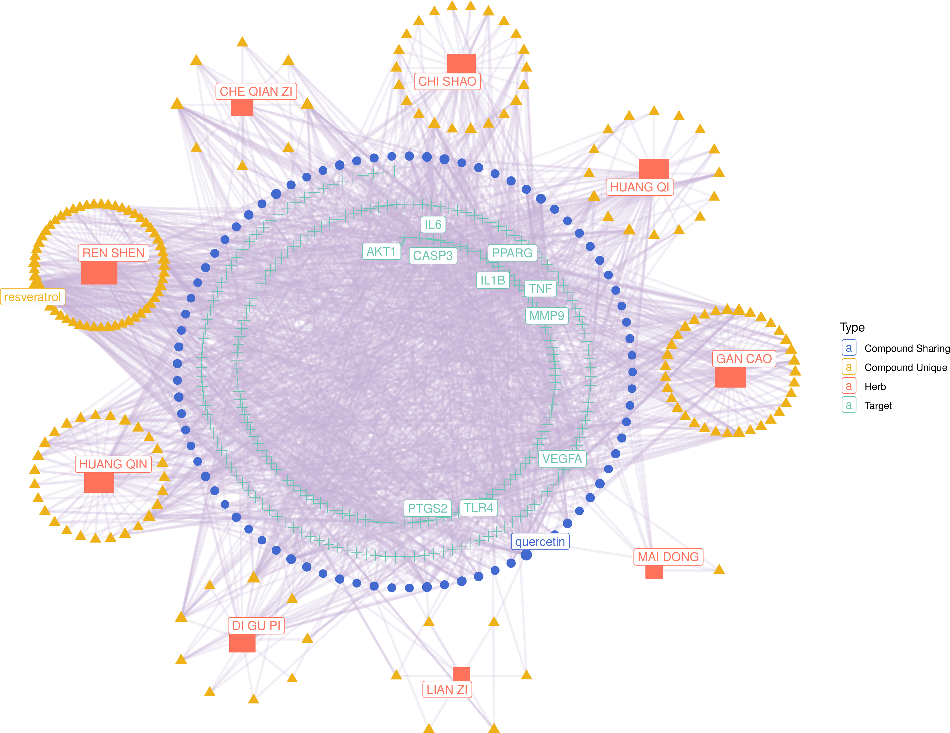

**Fig.** QINGXIN network pharmacology with disease

**(File path: Figure+Table/3.3_Network_疾病-成分-靶点_(QINGXIN)/QINGXIN-network-pharmacology-with-disease.pdf)**

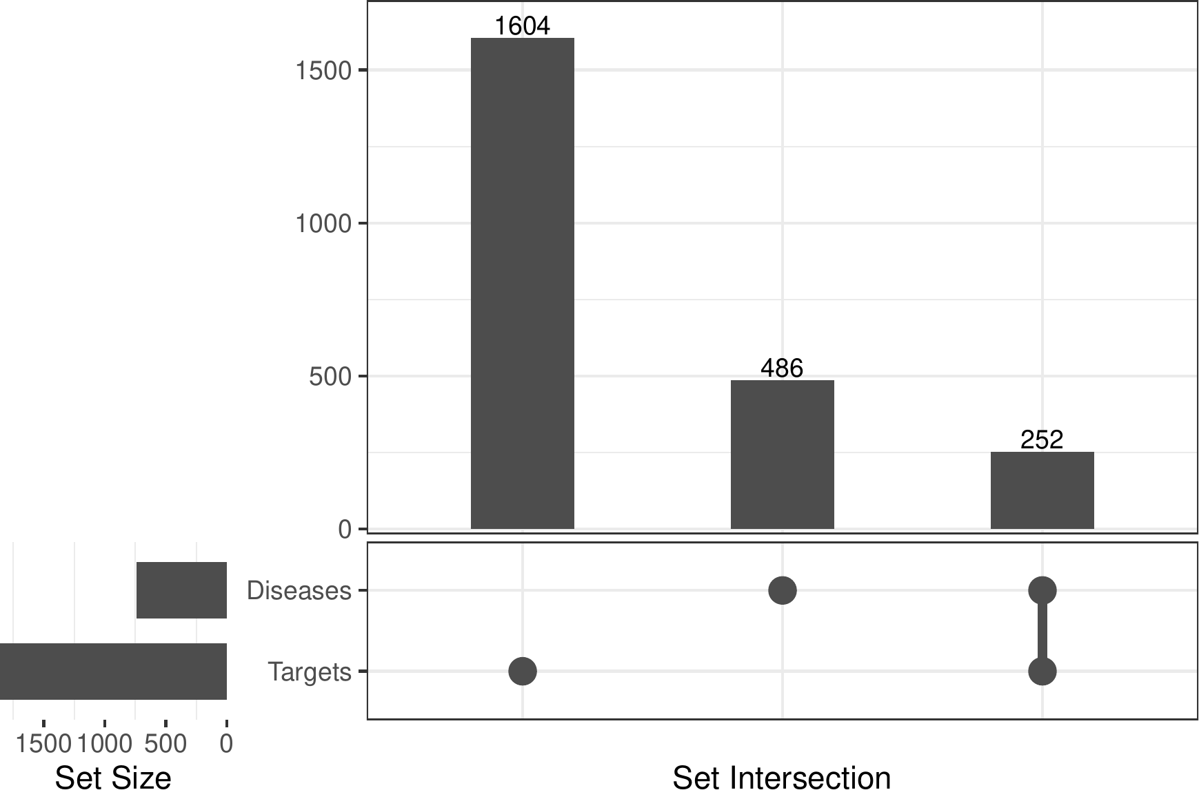

**Fig.** QINGXIN Targets intersect with targets of diseases

**(File path: Figure+Table/3.3_Network_疾病-成分-靶点_(QINGXIN)/QINGXIN-Targets-intersect-with-targets-of-diseases.pdf)**

* All_intersection: NPHS2, PKD2, FGF23, PKD1, CASR, AGT, KL, ACE, CRP, ALB, REN, TNFRSF11B, APOA1, EPO, NPHS1, LCN2, IL6, ADIPOQ, PTH, VDR, AGTR1, TNF, MTHFR, FN1, LEP, TGFB1, NOS3, INS, BGLAP, GLA, SPP1, NPPB, IGF1, MUC1, CBS, TF, EDN1, PON1, APOB, AGXT, SOST, CD36, RETN, VEGFA, CCL2, GATM, TNFSF11, CETP, TRPC6, NPPA, TTR, CTNNB1, APRT, APOE, HMOX1, IGFBP3, CYP27B1, IL1B, THBD, FABP1, NR3C2, MIR21, ALPL, SLC12A3, LPL, HGF, MMP3, MMP1, TGFBR1, HMGB1, RBP4, HP, CALCA, AQP1, SLPI, MIR155, MMUT, MMP9, HAMP, SOD1, A…

**(See: Figure+Table/3.3_Network_疾病-成分-靶点_(QINGXIN)/QINGXIN-Targets-intersect-with-targets-of-diseases-content)**

## 3.4 FerrDb 铁死亡调控因子 (FERR)

铁死亡相关调控因子统计：marker (n=9) , driver (n=264) , suppressor (n=238) , unclassifier (n=110)

## 3.5 FerrDb 与铁死亡相关基因的交集 (FERR)

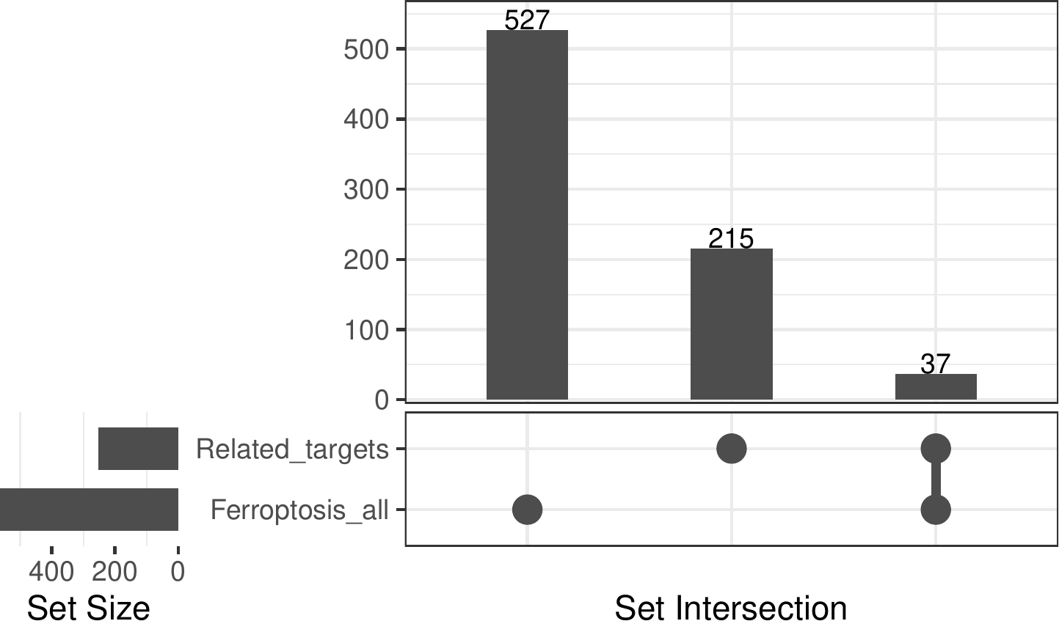

**Fig.** Intersection of Related targets with Ferroptosis all

**(File path: Figure+Table/3.5_FerrDb_与铁死亡相关基因的交集_(FERR)/Intersection-of-Related-targets-with-Ferroptosis-all.pdf)**

* All_intersection: ALB, LCN2, IL6, ADIPOQ, VDR, TGFB1, MUC1, CBS, TF, VEGFA, HMOX1, IL1B, TGFBR1, HMGB1, HAMP, IFNG, TLR4, NFE2L2, HIF1A, TIMP1, PPARG, GSTM1, FGF21, HNF4A, TP53, DPP4, MTOR, CDH1, NOX4, CP, IDO1, HBA1, PTGS2, GSK3B, HOTAIR, SLC11A2, KEAP1

**(See: Figure+Table/3.5_FerrDb_与铁死亡相关基因的交集_(FERR)/Intersection-of-Related-targets-with-Ferroptosis-all-content)**

## 3.6 富集分析 (COMMON)

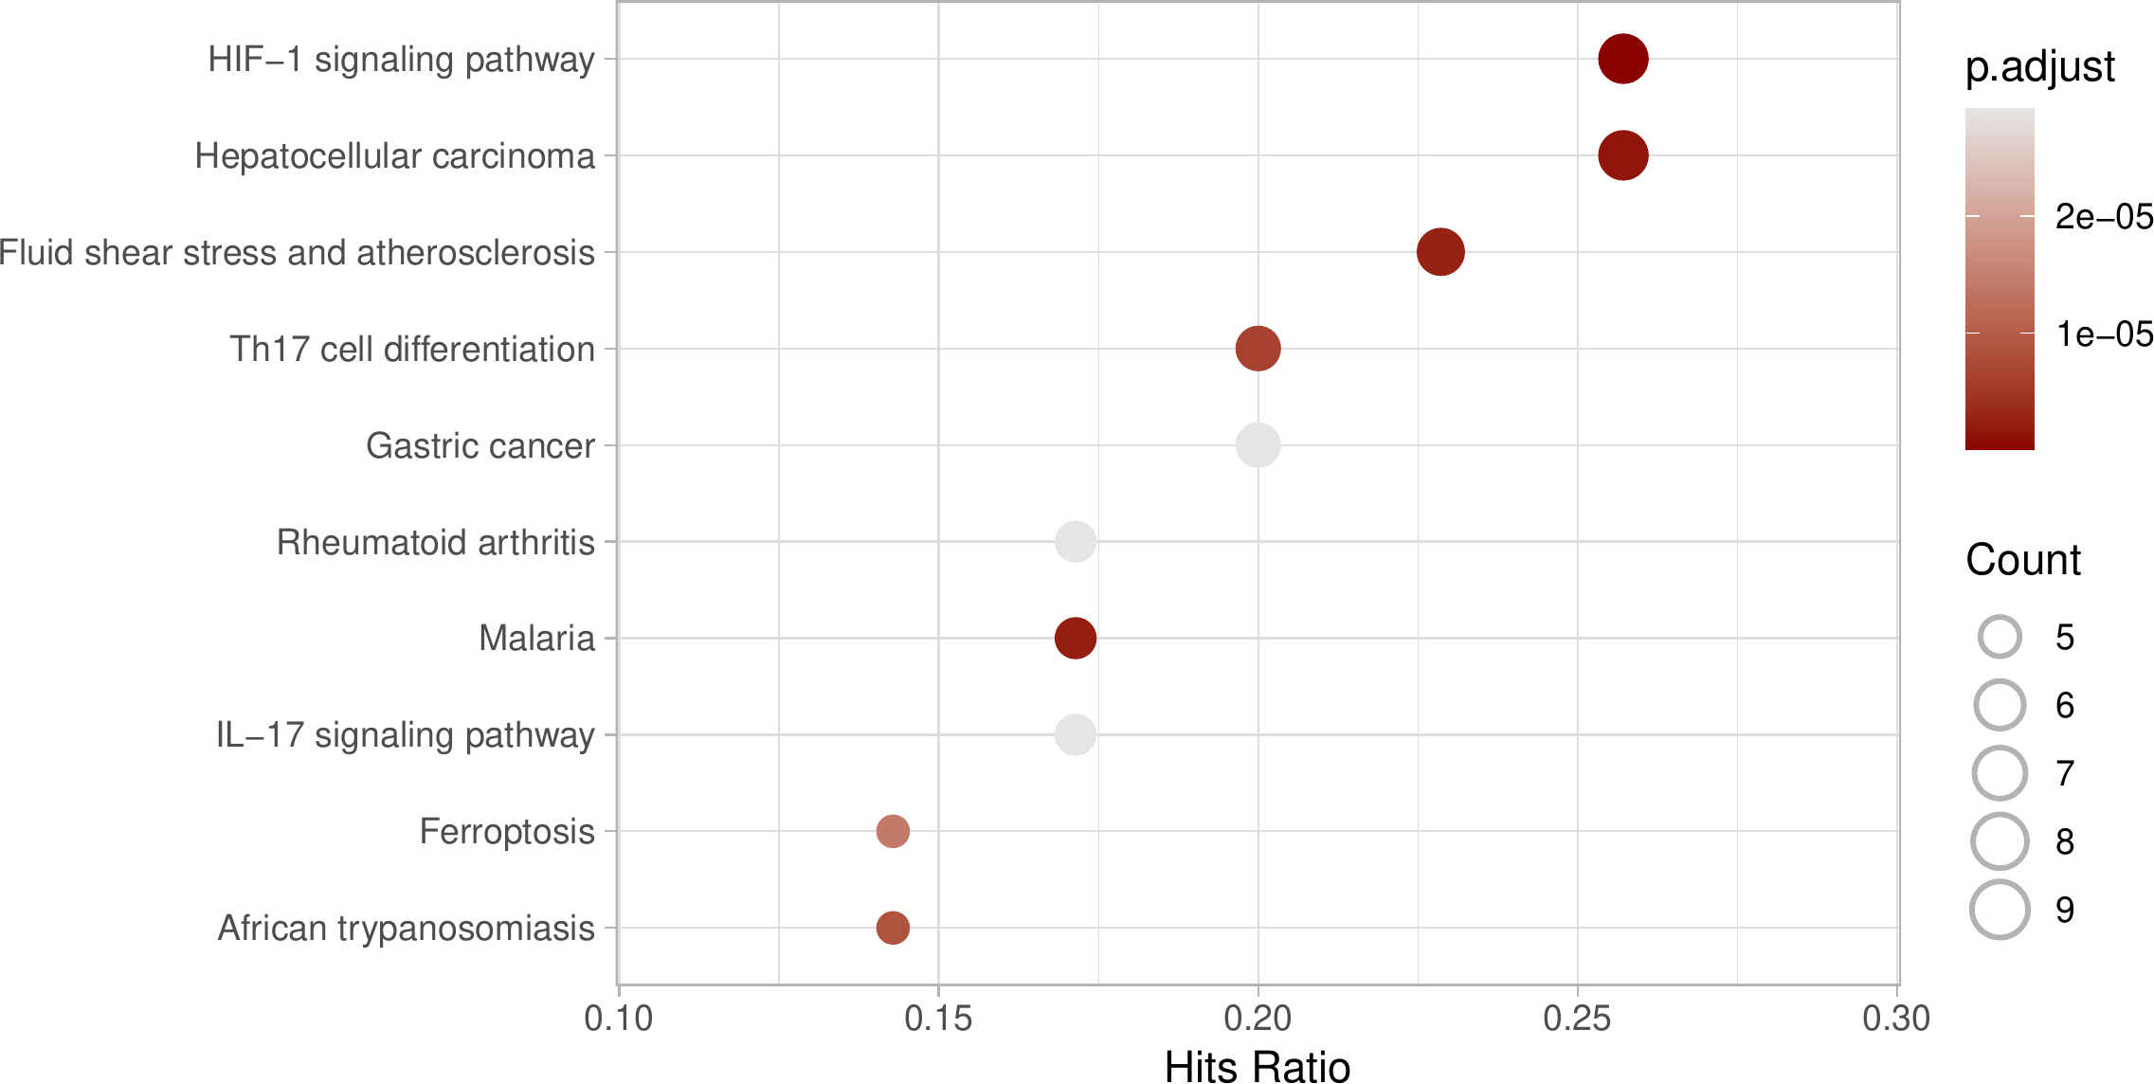

**Fig.** COMMON KEGG enrichment

**(File path: Figure+Table/3.6_富集分析_(COMMON)/COMMON-KEGG-enrichment.pdf)**

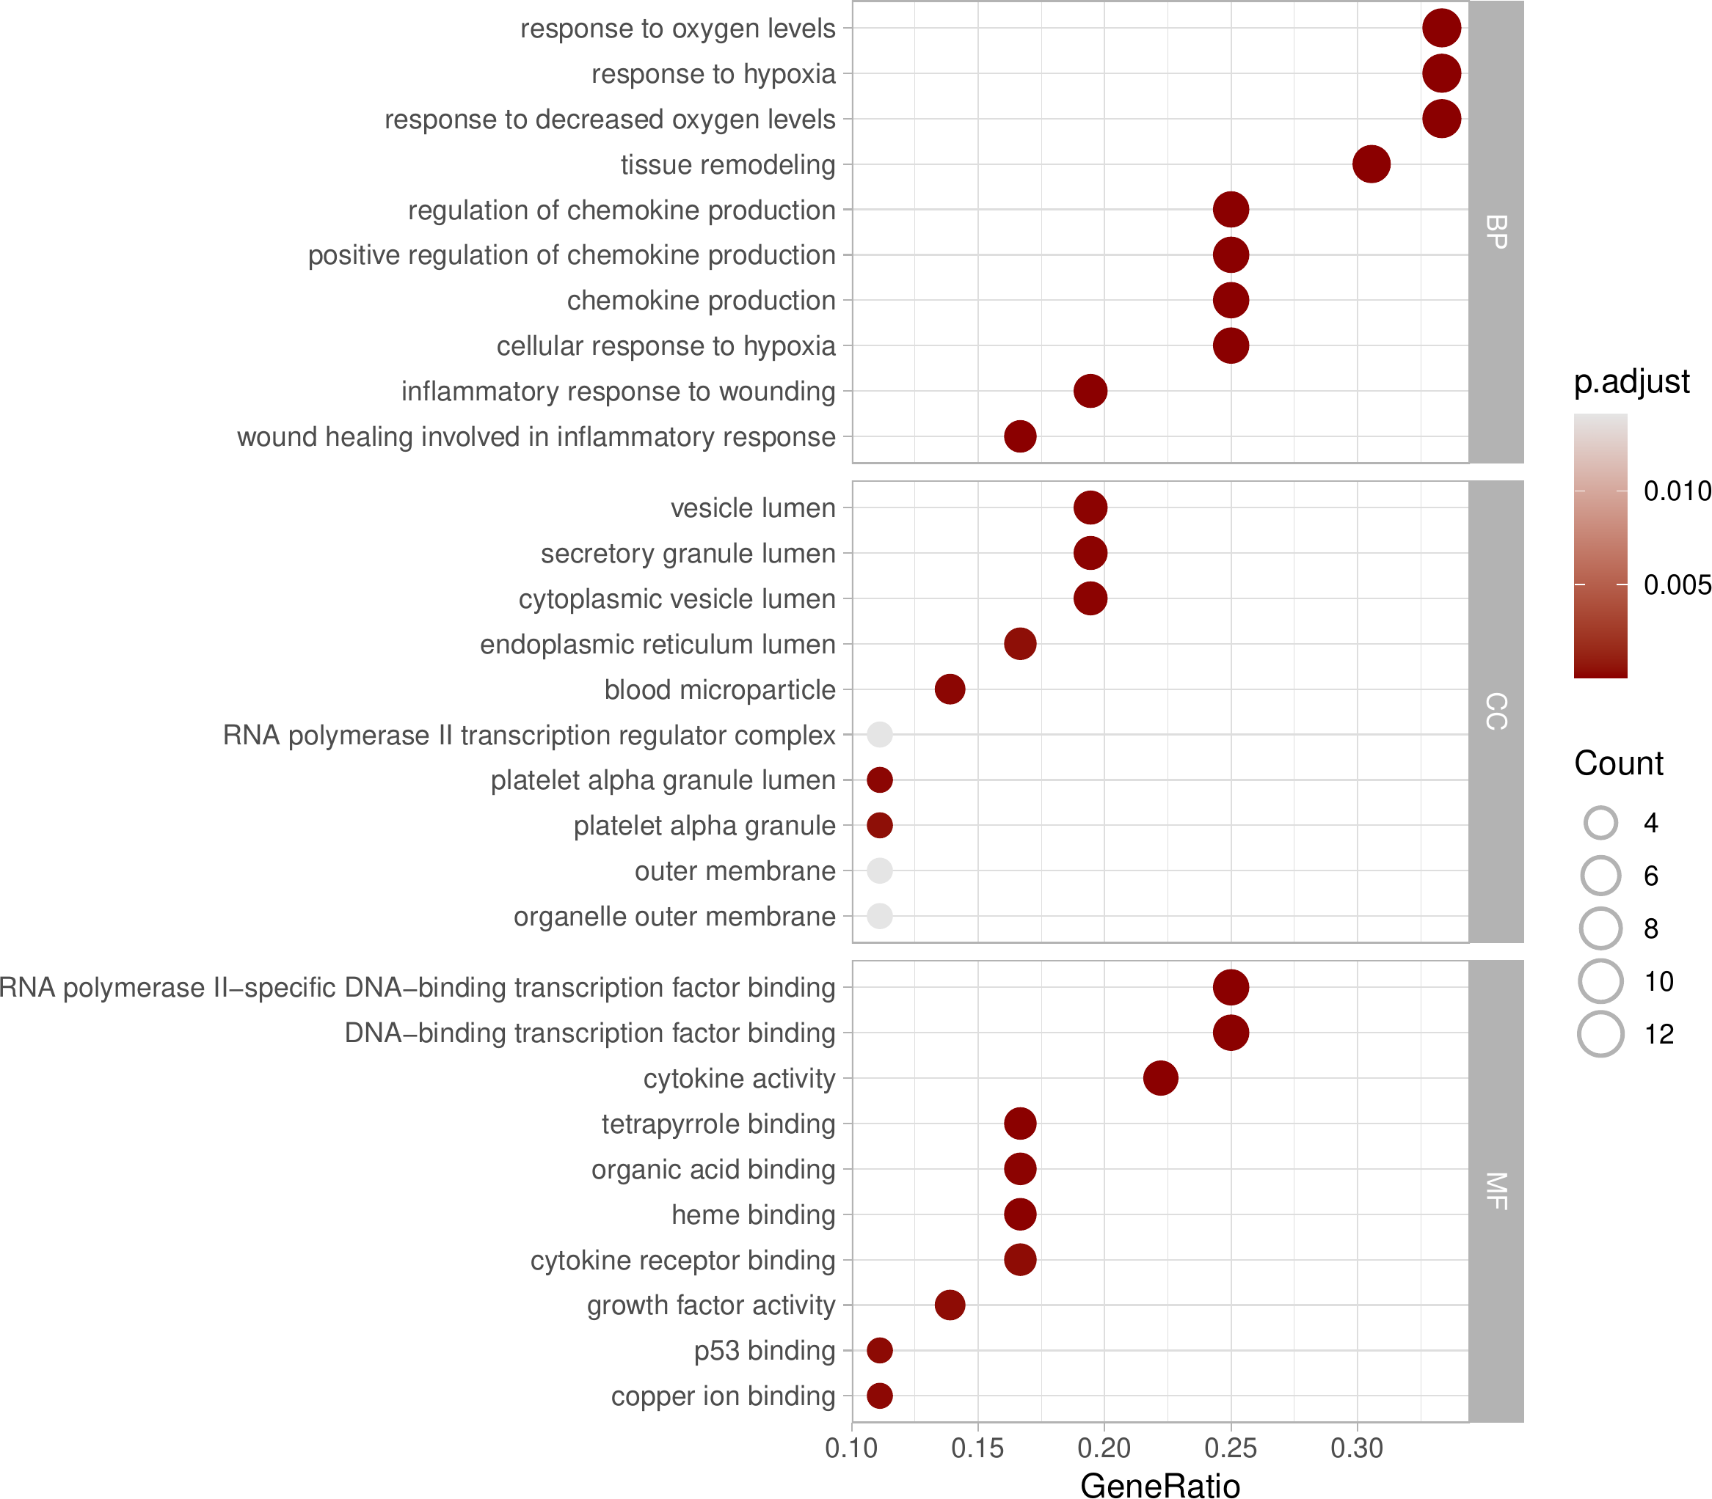

**Fig.** COMMON GO enrichment

**(File path: Figure+Table/3.6_富集分析_(COMMON)/COMMON-GO-enrichment.pdf)**

**Tab.** COMMON KEGG enrichment data

| Category | Subcat... | ID | Descri... | GeneRatio | BgRatio | Pvalue | P.adjust | Qvalue | GeneID |
| --- | --- | --- | --- | --- | --- | --- | --- | --- | --- |
| Enviro... | Signal... | Hsa04066 | HIF-1 ... | 9/35 | 110/8878 | 2.6671... | 4.8008... | 2.3583... | 3091/3... |
| Human ... | Cancer... | Hsa05225 | Hepato... | 9/35 | 170/8878 | 1.2895... | 1.1605... | 5.7011... | 2932/2... |
| Human ... | Infect... | Hsa05144 | Malaria | 6/35 | 50/8878 | 3.3575... | 2.0145... | 9.8958... | 3039/3... |
| Human ... | Cardio... | Hsa05418 | Fluid ... | 8/35 | 141/8878 | 5.4365... | 2.4464... | 1.2017... | 2944/3... |
| Organi... | Immune... | Hsa04659 | Th17 c... | 7/35 | 109/8878 | 1.7547... | 6.3172... | 3.1032... | 3091/3... |
| ... | ... | ... | ... | ... | ... | ... | ... | ... | ... |

**(File path: Figure+Table/3.6_富集分析_(COMMON)/COMMON-KEGG-enrichment-data.xlsx)**

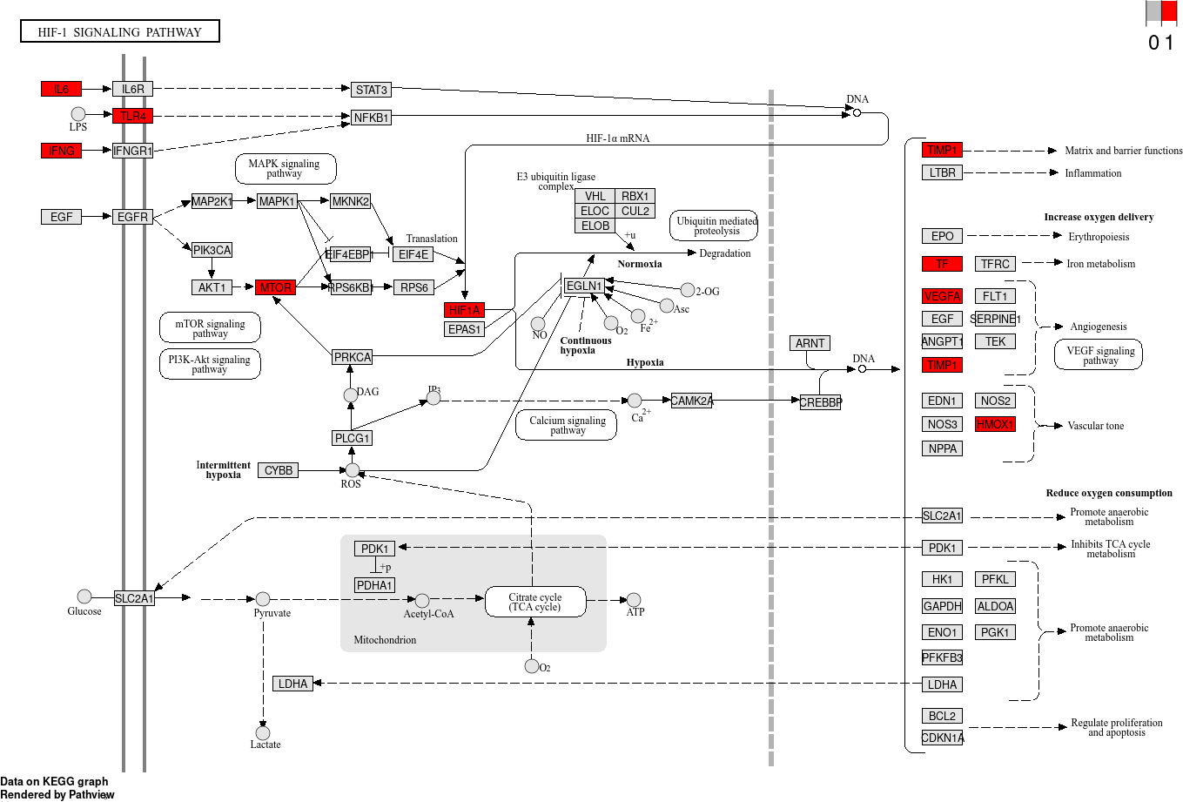

**Fig.** COMMON hsa04066 visualization

**(File path: Figure+Table/3.6_富集分析_(COMMON)/COMMON-hsa04066-visualization.png)**

* Interactive figure:
* Enriched genes: VEGFA, HIF1A, MTOR, TF, TIMP1, HMOX1, TLR4, IFNG, IL6

# 4 总结

调控铁死亡的通路可能是 HIF-1 ，见Fig. 。 其他可能的通路，见Tab.

# Reference

1. Kong, X. *et al.* BATMAN-tcm 2.0: An enhanced integrative database for known and predicted interactions between traditional chinese medicine ingredients and target proteins. *Nucleic acids research* **52**, D1110–D1120 (2024).

2. Durinck, S., Spellman, P. T., Birney, E. & Huber, W. Mapping identifiers for the integration of genomic datasets with the r/bioconductor package biomaRt. *Nature protocols* **4**, 1184–1191 (2009).

3. Stelzer, G. *et al.* The genecards suite: From gene data mining to disease genome sequence analyses. *Current protocols in bioinformatics* **54**, 1.30.1–1.30.33 (2016).

4. Zhou, N. *et al.* FerrDb v2: Update of the manually curated database of ferroptosis regulators and ferroptosis-disease associations. *Nucleic acids research* **51**, D571–D582 (2023).

5. Wu, T. *et al.* ClusterProfiler 4.0: A universal enrichment tool for interpreting omics data. *The Innovation* **2**, (2021).